Supplementary Information for
Suspension electrolyte for protecting aqueous zinc batteries from calendar aging
Authors: Jing Wang¹, Xun Guan¹, Hance Su¹, Junyan Li¹, Pu Zhang¹, Xiwen Chi¹, Yuqi Li¹, Yuxuan Chen¹, Zhouyi Chen¹, Sathya Narayanan Jagadeesan², Ajay Ravi¹, Haiyan Mao¹, Mun Sek Kim³, Xueli Zheng^{1,2}, Yi Cui^{1,2,4*}
Affiliations:
¹Department of Materials Science and Engineering, Stanford University, Stanford, CA 94305, USA.
²Stanford Institute for Materials and Energy Sciences, SLAC National Accelerator Laboratory, Menlo Park, CA 94025, USA.
³Department of Chemical Engineering, Stanford University, Stanford, CA 94305, USA.
⁴Department of Energy Science and Engineering, Stanford University, Stanford, CA 94305, USA.
*Corresponding author: yicui@stanford.edu

Table of Contents
Supplementary Note 1
Supplementary Figures S1-S21
Supplementary References

Supplementary Note 1: Optimization of Al₂O₃ concentration in suspension electrolytes
While the Al₂O₃ layer at Zn anode surface can limit direct contact between Zn and bulk water, it must remain sufficiently permeable to ensure Zn²⁺ conductivity. Too few particles yield incomplete coverage, while excessive loading can increase viscosity, reduce practical processability, and produce overly dense particle layers that hinder ion transport. Thus, optimizing Al₂O₃ concentration is essential to balance interfacial protection, Zn²⁺ conductivity, and manufacturability.
The influence of Al₂O₃ concentration was evaluated through ionic conductivity, Zn²⁺ transference number, viscosity, and electrochemical performance. Ionic conductivity of electrolytes remained similar up to 3 wt% but dropped significantly at higher concentrations (Figure S18). Meanwhile, the Zn²⁺ transference number increased from 0.26 in bare ZnSO₄ to 0.31 at 3 wt% Al₂O₃ and remained similar at higher concentrations (Figure S19). Viscosity increased gradually from ~2.0 mPa·s in pristine ZnSO₄ to ~3.0 mPa·s at 3 wt% Al₂O₃, which was sufficiently low for practical cell assembly and separator wetting (Figure S20). However, higher concentrations caused more substantial viscosity increases that may hinder large-scale processing. Figure S21 further illustrated the concentration dependence of Al₂O₃ suspensions in Zn||Cu half cells. At low concentration of 1 wt%, CE and cycle life were similar to pristine ZnSO₄, reflecting insufficient protection and transference number. Increasing concentration to 3 wt% markedly improved cycling stability, maintaining ~99.6% CE for over 550 cycles. Higher concentration (5–10 wt%) showed lower average CE and shortened cycle life, consistent with the reduced ionic conductivity and much higher viscosity. Overall, the Al₂O₃ suspension electrolyte achieved the optimal balance around 3 wt%, offering appropriate ionic conductivity, transference number, rheological properties, and the best long-term cycling performance.

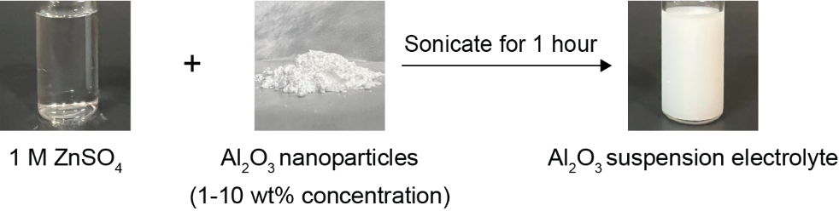
Supplementary Figure S1. Preparation of Al₂O₃ suspension electrolytes. Al₂O₃ nanoparticles (1–10 wt%) were dispersed in 1 M ZnSO₄ solution and sonicated for 1 hour to obtain a uniform Al₂O₃ suspension electrolyte.

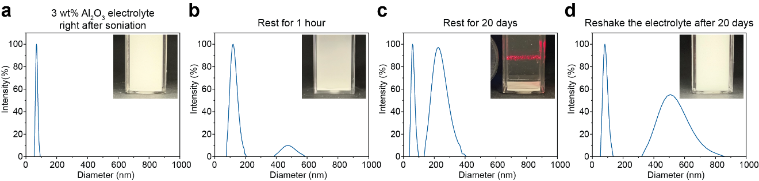
Supplementary Figure S2. Distribution of Al₂O₃ particle sizes in 3 wt% suspension electrolyte measured by DLS at different resting conditions: a) immediately after sonication, b) after 1-hour rest, c) after 20-day rest, and d) after reshaking following 20-day rest. Insets show corresponding optical images.

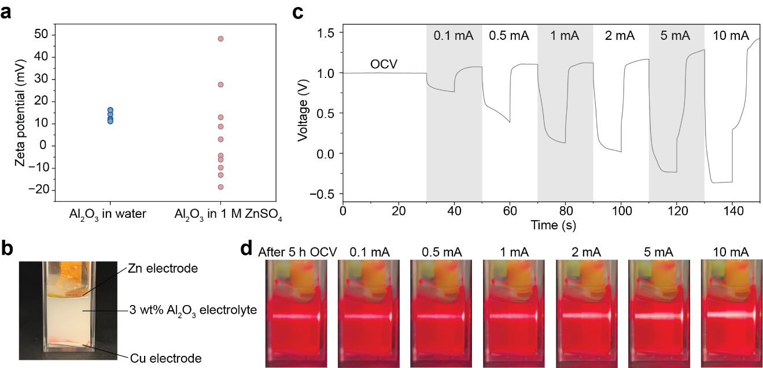
Supplementary Figure S3. Dielectrophoretic mobility of Al₂O₃ particles in ZnSO₄. a) Zeta potential of Al₂O₃ particles measured in DI water and 1 M ZnSO₄, showing the shift from moderately positive charge in water to a broad distribution (−20 to +50 mV) in ZnSO₄. b) The separator-free Zn||Cu cuvette cell used to visualize particle redistribution. c) Applied protocol with stepwise current densities from 0.1 to 10 mA cm⁻² under alternating polarity. d) Tyndall effect images showing Al₂O₃ particle redistribution under different applied current densities.

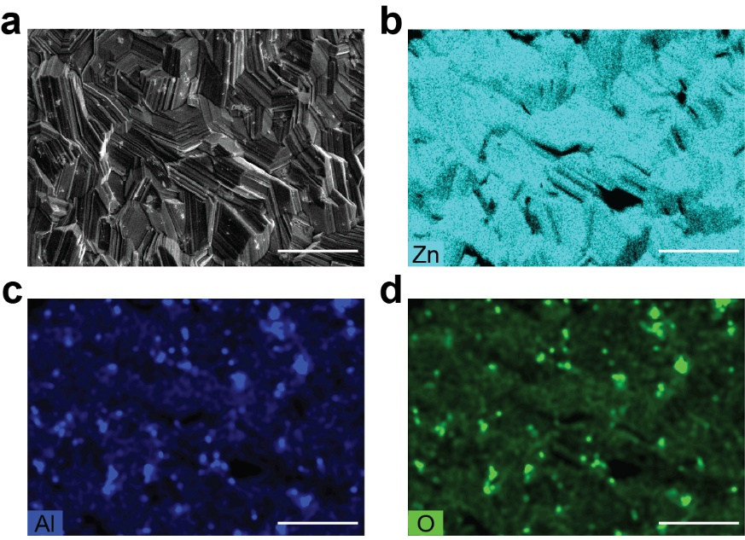
Supplementary Figure S4. EDS elemental maps of electroplated 10 mAh cm⁻² Zn in the Al₂O₃ suspension electrolyte at 10 mA cm⁻². a) SEM image, b) Zn map, c) Al map, and d) O map. Scale bars: 10 µm.

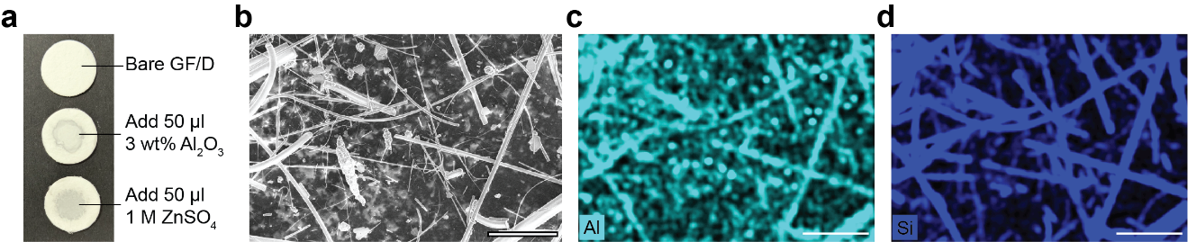
Supplementary Figure S5. Al₂O₃ particles in GF/D separator. a) Photos of a bare GF/D separator, after adding 50 µl of 3 wt% Al₂O₃ suspension electrolyte, and after adding 50 µl of 1 M ZnSO₄ electrolyte. b) SEM image, c) Al map, and d) Si map of the separator interior from a Zn||Cu cell after 50 cycles at 1 mA cm⁻² and 1 mAh cm⁻². Scale bars: 30 µm.

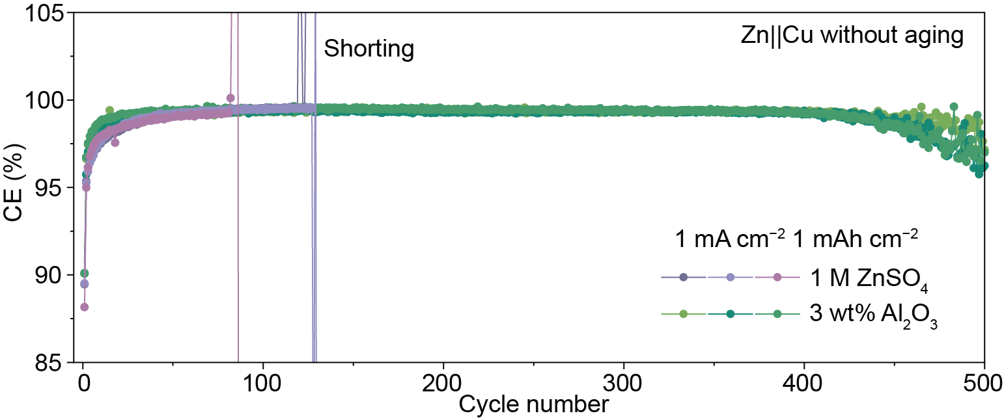
Supplementary Figure S6. Long-term performance of Zn||Cu cells with 1 M ZnSO₄ and 3 wt% Al₂O₃ suspension electrolytes under continuous cycling protocol without calendar aging at 1 mA cm⁻² and 1 mAh cm⁻².

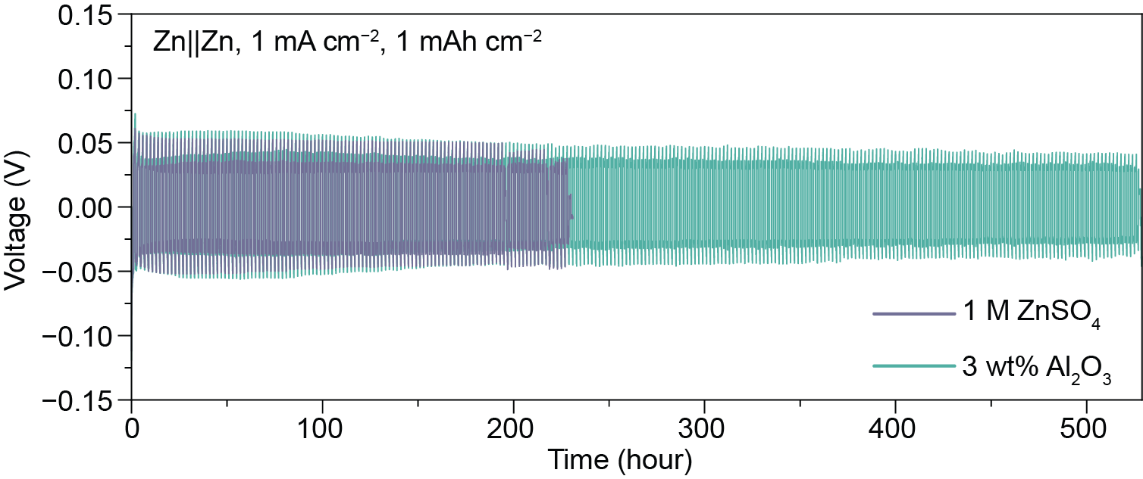
Supplementary Figure S7. Long-term cycling performance of Zn||Zn symmetric cells at 1 mA cm⁻² and 1 mAh cm⁻².

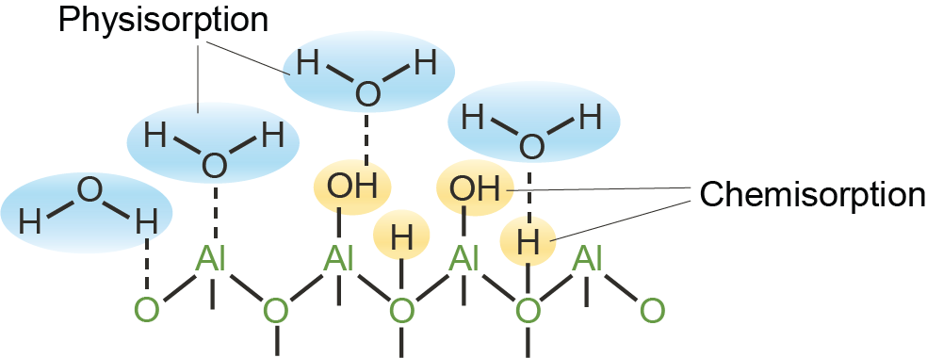
Supplementary Figure S8. Schematic illustration of the interactions among Al₂O₃ and water molecules.^{[1]}

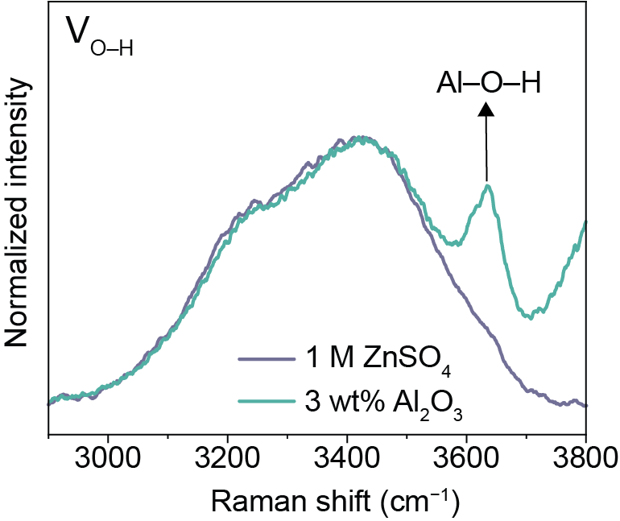
Supplementary Figure S9. Raman spectra of electrolytes in O–H stretching vibration band. The distinct peak at ~3650 cm^{–1} corresponds to the hydroxyl groups on Al₂O₃ in the suspension electrolyte.^{[1,2]}

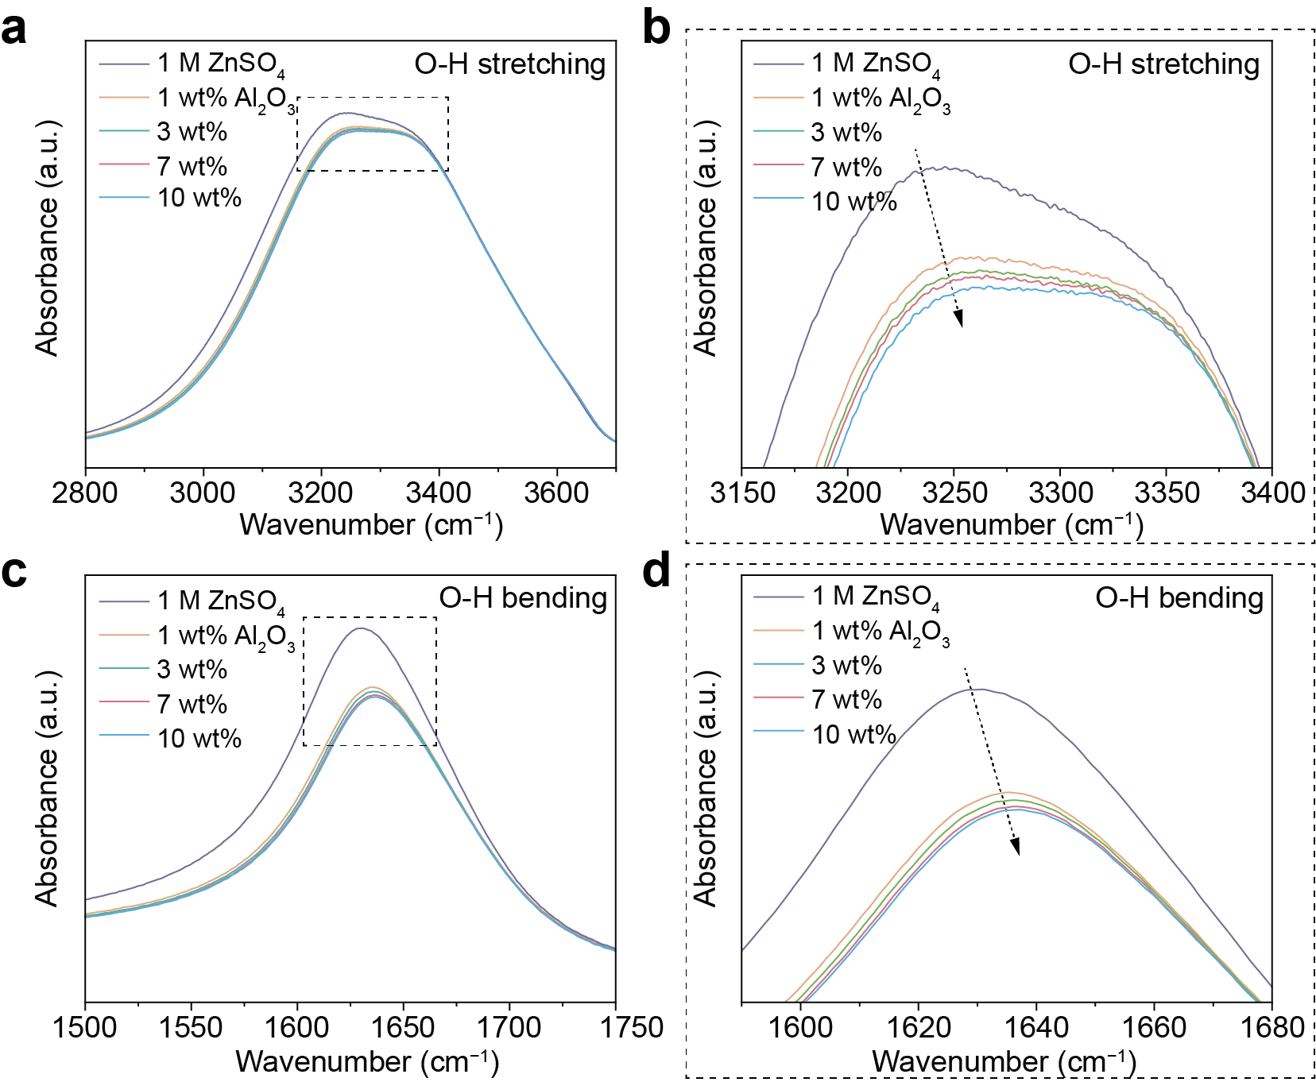
Supplementary Figure S10. FTIR spectra of electrolytes with different Al₂O₃ concentrations in (a) O–H stretching band and (c) O–H bending band of H₂O. (b) and (d) are the corresponding magnified views of (a) and (c), respectively.

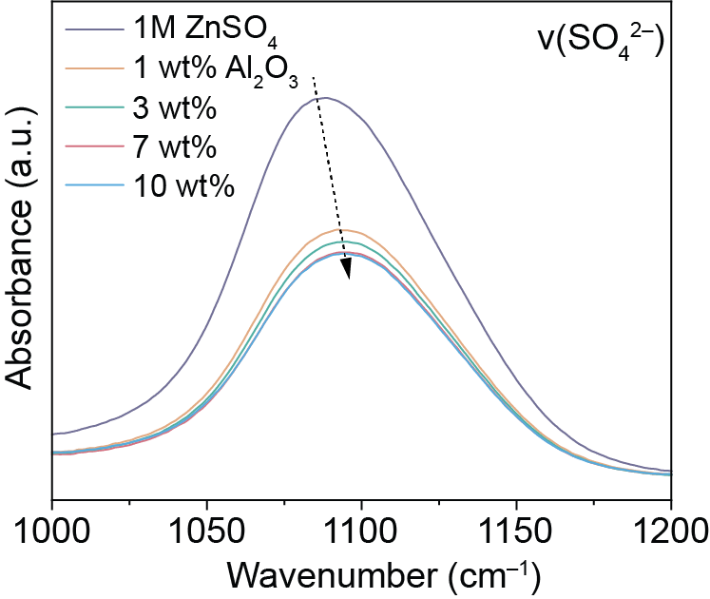
Supplementary Figure S11. FTIR spectra of electrolytes with different Al₂O₃ concentrations in ν(SO₄²⁻) vibration band.

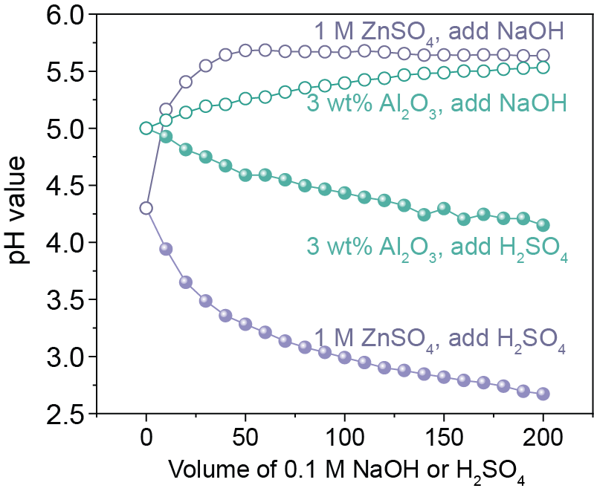
Supplementary Figure S12. Acid/base titrations in 1 M ZnSO₄ and 3 wt% Al₂O₃ suspension electrolytes upon incremental addition of 0.1 M NaOH or H₂SO₄.

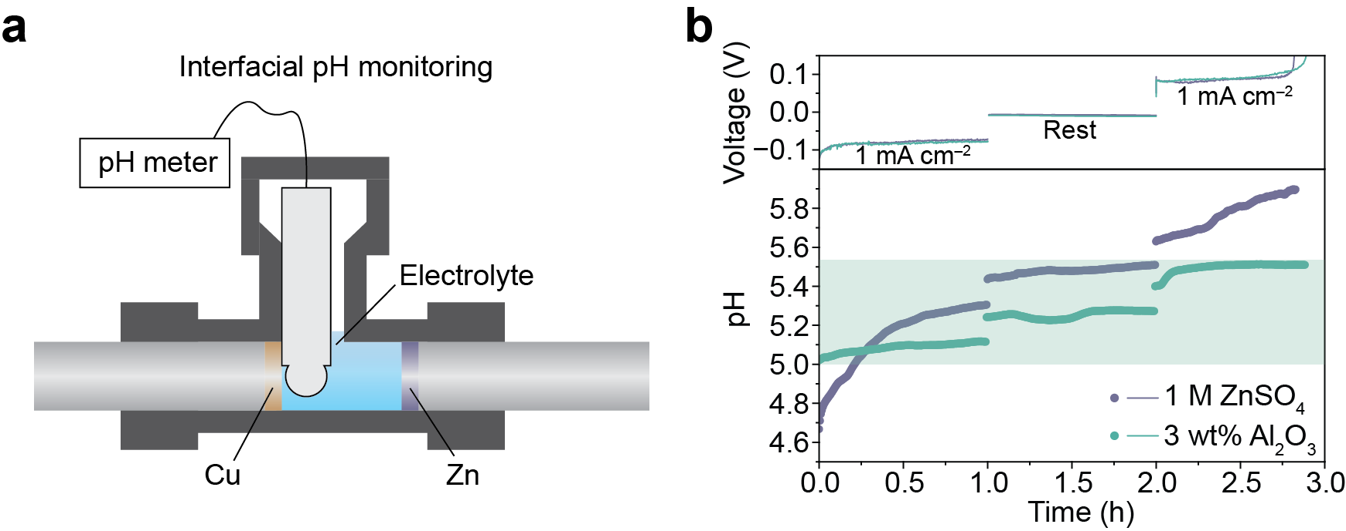
Supplementary Figure S13. a) Schematic of interfacial pH monitoring setup. b) The interfacial pH variation and voltage profiles with different electrolytes.

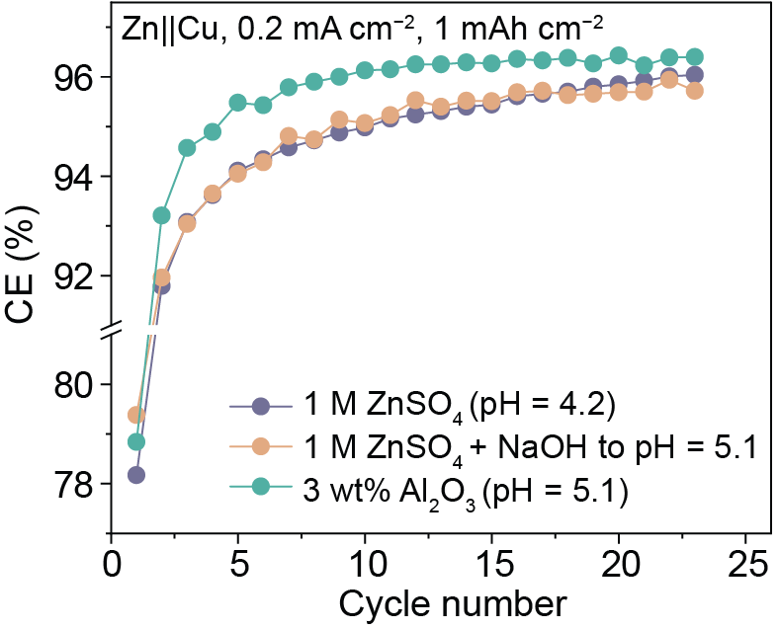
Supplementary Figure S14. CE performance of Zn||Cu cells at 0.2 mA cm⁻² and 1 mAh cm⁻² with different electrolytes: 1 M ZnSO₄ with pH = 4.2, 1 M ZnSO₄ adjusted with NaOH to pH = 5.1, and 3 wt% Al₂O₃ suspension electrolyte with pH = 5.1.

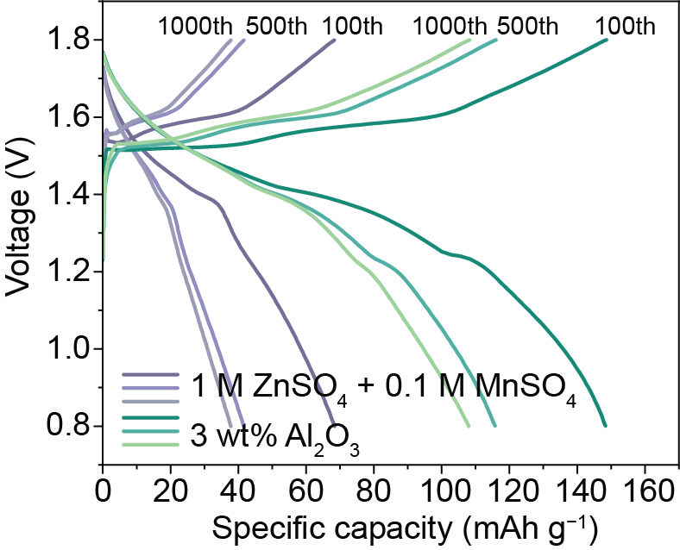
Supplementary Figure S15. GCD profiles of Zn||MnO₂ full cells at 100th, 500th, and 1000th cycle numbers during long-term cycling at 1 A g⁻¹ without aging.

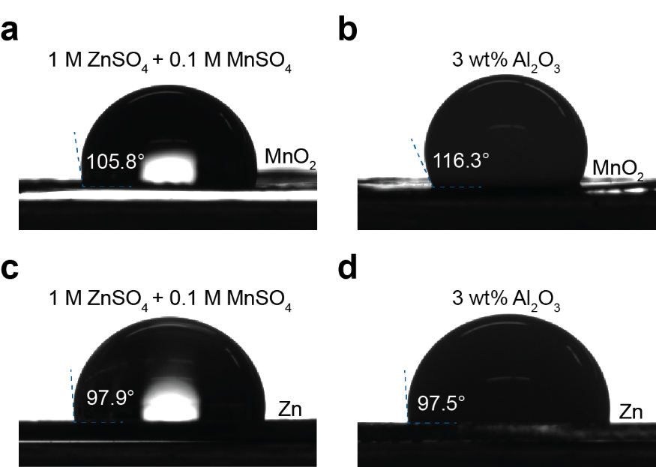
Supplementary Figure S16. Contact angle goniometry of a) control and b) suspension electrolytes on MnO₂ cathode and c), d) Zn anode.

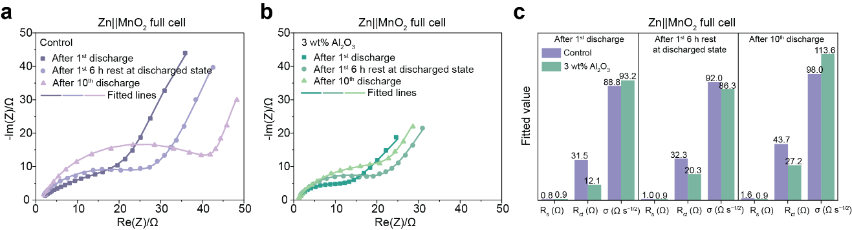
Supplementary Figure S17. The EIS spectra of Zn||MnO₂ full cells with a) 1 M ZnSO₄ + 0.1 M MnSO₄ (control) and b) 1 M ZnSO₄ + 0.1 M MnSO₄ + 3 wt% Al₂O₃ suspension electrolytes. The full cells were cycled at 1 A g⁻¹ with 6 h calendar aging after each charge and discharge step. c) Fitted R_{s}, R_{ct} and Warburg coefficient. The fitted Warburg coefficient (σ, Ω·s^{−1/2}) reflects the diffusion-related impedance, where a larger σ indicating larger diffusion impedance (W) according to the relationship W =σω^{−1/2} − jσω^{−1/2}.^{[3]}

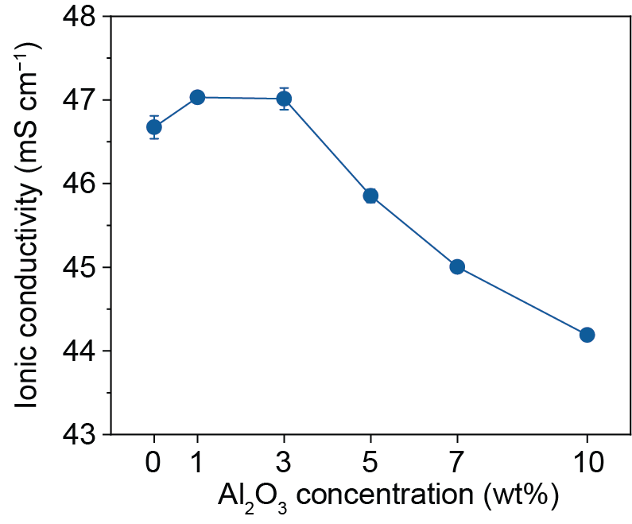
Supplementary Figure S18. Ionic conductivity of electrolytes containing different concentrations of Al₂O₃ measured by a conductivity meter. The error bars represent the standard deviation of three independent measurements.

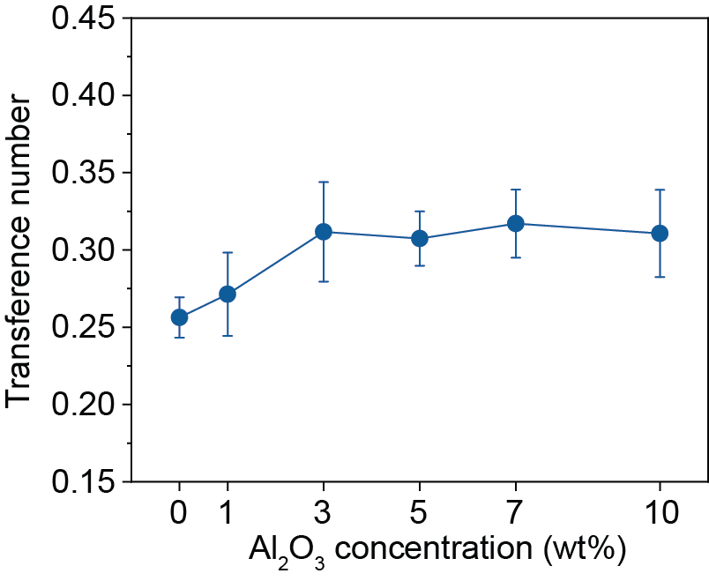
Supplementary Figure S19. Zn²⁺ transference number of electrolytes containing different concentrations of Al₂O₃ calculated by Bruce-Vincent method in Zn||Zn cells.^{[4]} The error bars represent the standard deviation of three independent measurements.

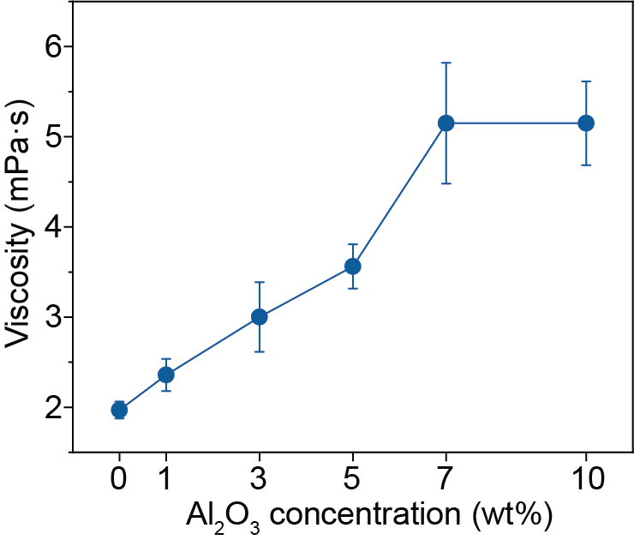
Supplementary Figure S20. Viscosity of electrolytes containing different concentrations of Al₂O₃ in 1 M ZnSO₄. The error bars represent the standard deviation of three independent measurements.

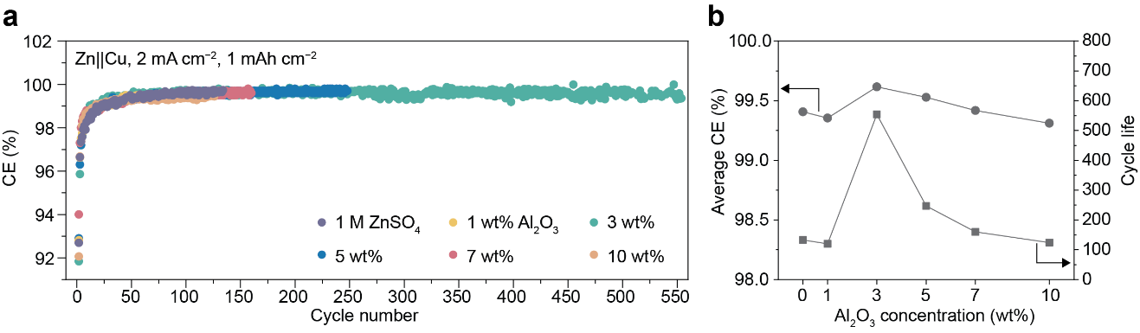
Supplementary Figure S21. a) Long-term cycling performance of Zn||Cu half cells with different Al₂O₃ concentrations at 2 mA cm⁻² and 1 mAh cm⁻². b) Average CE and the number of cycle life in a).

Supplementary References
(1) Hass, K. C.; Schneider, W. F.; Curioni, A.; Andreoni, W. First-Principles Molecular Dynamics Simulations of H₂O on α-Al₂O₃ (0001). J. Phys. Chem. B 2000, 104 (23), 5527–5540. https://doi.org/10.1021/jp000040p.
(2) Ranea, V. A.; Carmichael, I.; Schneider, W. F. DFT Investigation of Intermediate Steps in the Hydrolysis of α-Al₂O₃(0001). J. Phys. Chem. C 2009, 113 (6), 2149–2158. https://doi.org/10.1021/jp8069892.
(3) Choi, W.; Shin, H.-C.; Kim, J. M.; Choi, J.-Y.; Yoon, W.-S. Modeling and Applications of Electrochemical Impedance Spectroscopy (EIS) for Lithium-Ion Batteries. J. Electrochem. Sci. Technol 2020, 11 (1), 1–13. https://doi.org/10.33961/jecst.2019.00528.
(4) Evans, J.; Vincent, C. A.; Bruce, P. G. Electrochemical Measurement of Transference Numbers in Polymer Electrolytes. Polymer 1987, 28 (13), 2324–2328. https://doi.org/10.1016/0032-3861(87)90394-6.

